Ex.No. 14: 5G Throughput vs SNR with Modulation Labels
Objective 1:
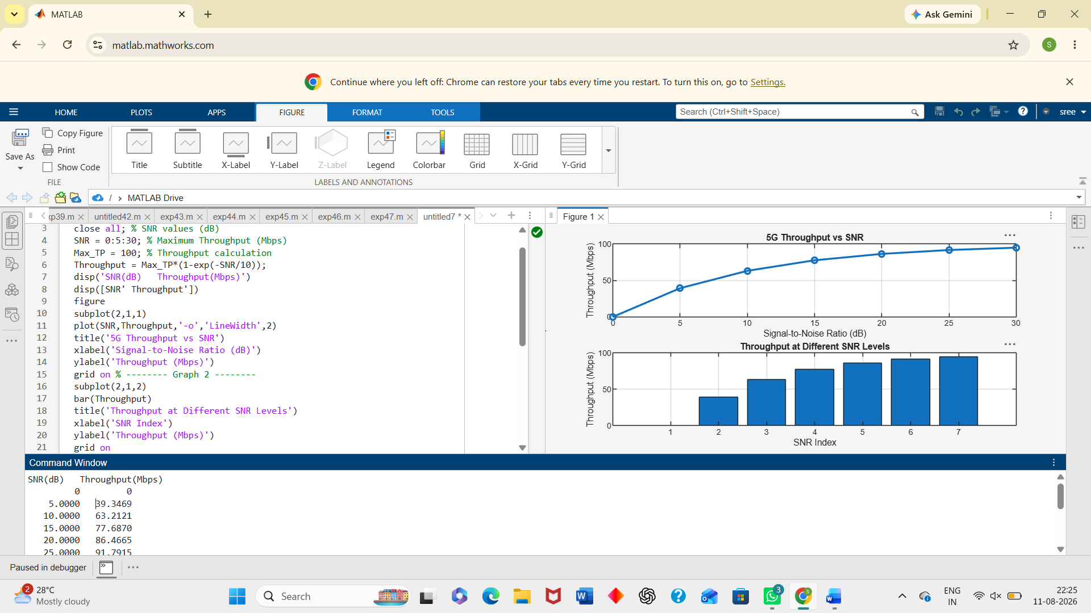
Objective 2:
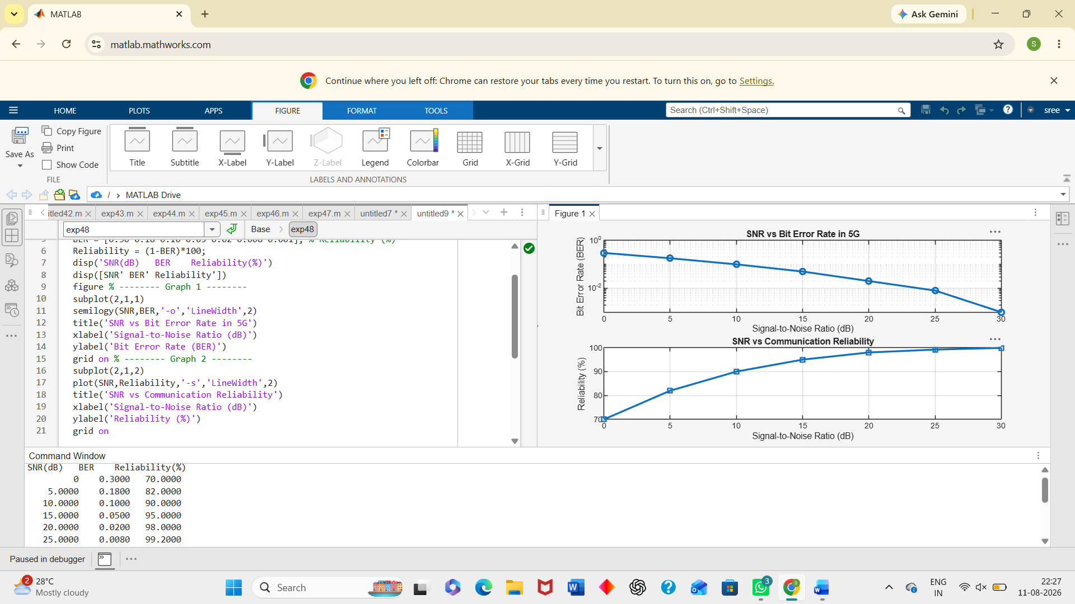
Objective 3:
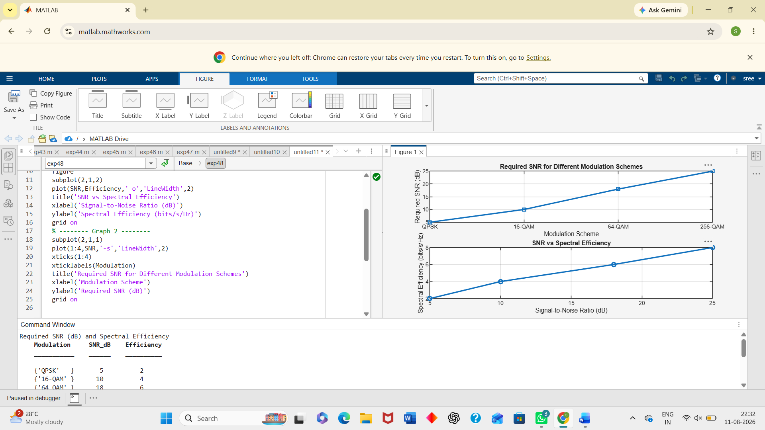
Result:
The Throughput (Mbps) of the 5G communication system increased with increasing Signal-to-Noise Ratio (SNR), demonstrating improved data transmission performance. The simulation showed that higher SNR (dB) reduced transmission errors and enhanced the reliability and quality of 5G communication. The comparison of QPSK, 16-QAM, 64-QAM, and 256-QAM revealed that higher order modulation schemes achieved greater throughput and spectral efficiency but required higher SNR for reliable communication.

